
SCHOOL OF COMPUTING AND ENGINEERING SCIENCES (SCES)
BACHELOR OF SCIENCE IN ELECTRICAL AND ELECTRONICS
ENGINEERING (BSEEE)
CONTROL SYSTEMS 2
Lab 2:
Analogue Lead, Lag Controllers Analysis and Implementation

Group 8 Members:
141962 – Ng’ang’a Samuel Mwichigi
143367 - Ian Katuku
145709 - Shanice Mwenda.
145527 - Abigail Wangechi.
142092 - Edward Aribu.

Table of Contents
List of figures 2
Abstract 3
Objective: 3
3. Learning Outcome: 3
Questions 3
Introduction 5
1.1 Lead and lag compensation preparation 6
1.2 Lead and lag compensation 7
1.3 MATLAB analysis 9
1.3.1 RLC network 9
1.3.2 Lead network 10
1.3.3 Lag network 11
1.3.4 Materials and requirements 12
Analysis 16
Conclusion 16
Challenges and Improvements: 16
References 17

List of figures
Figure 1: An RLC circuit. 5
Figure 2: A lead/lag network for the RLC circuit. 6
Figure 3: RLC network. 6
Figure 4: Step response for the uncompensated RLC network. 10
Figure 5. step response 12
Figure 6. bode plots 12
Figure 7 simulated circuit. 13

Abstract
This experiment focused on implementing lead and lag compensators within an RLC circuit to observe their effects on system response. A lead compensator was expected to enhance response speed, while a lag compensator aimed to improve system damping. The transfer functions were derived and analyzed for phase margin and frequency response, providing insights into transient and steady-state improvements in control systems.

Objective:
1 Build a Lead controller for an RLC network
2 Build a Lag controller for an RLC network
3 Plot the time response of the RLC network containing a forward loop lead compensator
4 Plot the time response of the RLC network containing a forward loop lag compensator

3. Learning Outcome:
1 Show that forward loop lead network improves the speed of response of RLC network.
2 Show that forward loop lag network increases the damping of the RLC network.

Questions
- Where can we use the lead network?
A lead network is often used in situations where improved transient response is required, particularly to:
Increase system stability: Lead networks can increase the system's phase margin, enhancing stability and reducing overshoot.
Improve response speed: By adding phase lead, the network helps the system reach its desired output more quickly, reducing rise and settling times.
Compensate for slow dynamics: When a system has inherent lagging characteristics (e.g., large inertia in mechanical systems), a lead network can offset this lag, allowing for quicker response.
Applications for Lead Networks:
Robotics and automotive control: Where precise and fast response is essential, such as in steering and navigation systems.
High-speed automation: In processes where delays can lead to errors or inefficiencies, like conveyor systems or CNC machining.
Power systems: Used in generators or grid control to ensure rapid response to load changes and maintain system stability.
- Where can we use the lag network?
A lag network is beneficial in situations requiring improved steady-state accuracy and noise filtering, particularly to:
Reduce steady-state error: Lag networks improve accuracy by amplifying the low-frequency components of a signal, which enhances the system's ability to track the desired setpoint over time.
Filter high-frequency noise: The lag network helps attenuate high-frequency signals or noise, making it useful in systems sensitive to noise.
Stabilize systems with rapid fluctuations: Lag networks add a phase lag, which can dampen fast changes in the system, making it less sensitive to sudden fluctuations.
Applications for Lag Networks:
Temperature control systems: Where slow, smooth responses are preferable, such as in HVAC systems or industrial ovens.
Instrumentation and measurement: Used in sensors and measurement systems to ensure noise does not affect the readings.
Low-speed processes: Such as chemical mixing or slow-moving mechanical systems, where steady-state accuracy is crucial, and high-speed adjustments are unnecessary.
How does the phase lag compensator change the transient response of the RLC net-
work?

Introduction
In control systems, lead and lag compensators are critical for shaping system dynamics. This lab explored an RLC circuit where a lead compensator was designed to improve response speed, and a lag compensator to increase damping, stabilizing the system response. The goal was to analyze each compensator's effect on an RLC network, interpreting changes in response through transfer functions, step response, and Bode plots.

2. Preparation
Preparation included analyzing the theoretical transfer functions of the RLC network and compensators. MATLAB was used to simulate both Bode and step response plots for each configuration. Circuit diagrams (Figure 1 and 2) illustrate the setup of the RLC network and compensators, respectively. Calculations were completed to determine effective transfer functions, as shown below:

The figure below shows the circuit diagram of an RLC network. If the capacitor has no charge and the switch, S₁ is closed at t = 0, the charging of capacitor C, and output voltage V_{C}(t) produces a time response similar to a second order control system response to a unit step.
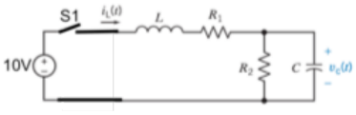
Figure 1: An RLC circuit.
- R1 = 220 Ω
- R1 = 220 Ω
- C = 2.2 nF.
- L = 100µH
A lead/lag network shown in the figure below is built to change the time response of the RLC network an inserted between the 10V source and switch S₁.
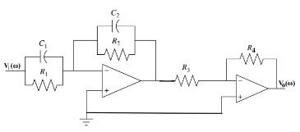
Figure 2: A lead/lag network for the RLC circuit.

Lead and lag compensation preparation
Show that the RLC circuit transfer function is given as:
$$G_{p}= \frac{10}{s(s^{2}L + s\left(\frac{L}{R_{2}}+C_{1}\right)+(1+\frac{R_{1}}{R_{2}})}$$

Solution:

Figure 3: RLC network.
Convert the circuit elements to the s-domain using Laplace transform
- The impedance of a capacitor C, in s-domain is: $Z_{c}=\frac{1}{sC}$
- The impedance of an inductor L, in s-domain is: $Z_{L}=sL$
- The constant d.c source in s-domain is given by: $10V=\frac{10}{s}$
Calculate the effective impedance of R₂ and capacitor, C which are connected in parallel.
$$R_{2}||C= \frac{R_{2}}{sCR_{2}+1}$$
Since R₂ and the capacitor are in parallel, the volage across them is the same. This voltage is denoted as V_{C}(t). In the s-domain, we represent this voltage as V_{C}(s).
By using the voltage division rule, V_{C}(s) can be calculated as:
$$V_{c\left(s\right)}=\frac{(\frac{R_{2}}{\left(sCR_{2}+1\right)})(\frac{10}{s})}{sL+R_{1}+\left(\frac{R_{2}}{SCR_{2}+1}\right)}$$

Multiplying both the numerator and the denominator with $s^{2}CR_{2}+s$ gives:
$$G_{p}=\frac{10R_{2}}{\left(s^{2}CR_{2}+s\right)sL+\left(s^{2}CR_{2}+s\right)R_{1}+sR_{2}}$$
Simplifying the denominator gives:
$$\left(s^{2}CR_{2}+s\right)sL+\left(s^{2}CR_{2}+s\right)R_{1}+sR_{2}= s^{3}CR_{2}L+ s^{2}L+ s^{2}CR_{2}R_{1}+sR_{2}+sR_{2}$$
Factoring s will give:
$$s^{3}CR_{2}L+ s^{2}L+ s^{2}CR_{2}R_{1}+sR_{2}+sR_{2}=s(s^{2}CR_{2}L+sL+sCR_{2}R_{1}+R_{1}+R_{2})$$
$$s\left(s^{2}CR_{2}L+sL+sCR_{2}R_{1}+R_{1}+R_{2}\right)= s(s^{2}CR_{2}L+s(L+CR_{2}R_{1})+R_{1}+R_{2})$$
The voltage across the capacitor can therefore be written as:
$$V_{C}\left(s\right)=\frac{10R_{2}}{s\left(s^{2}CR_{2}L+s\left(L+CR_{2}R_{1}\right)+R_{1}+R_{2}\right)}$$
Dividing the numerator and the denominator with R₂ gives:
$$V_{C}\left(s\right)=\frac{10}{(s\left(s^{2}LC+s\left(\frac{L}{R_{2}}+CR_{1}\right)+\left(\frac{R_{1}}{R_{2}}+1\right)\right)}$$

Lead and lag compensation
Show that for the lead/lag controller shown in fig.2 the transfer function is given as:
$$G_{clead}=\frac{V_{o}\left(s\right)}{V_{i}\left(s\right)}=\frac{R_{4}C_{1}}{R_{3}C_{2}}\left(\frac{s+\frac{1}{R_{1}C_{1}}}{s+\frac{1}{R_{2}C_{2}}}\right)$$
Solution

Figure 3: A lead/lag network for the RLC circuit.
For the first op amp, we need to calculate the effective impedance of R₁ and C₁ and that of R₂ and C₂.
$$R_{1}||C_{1}= \frac{R_{1}}{sC_{1}R_{1}+1}$$
$$R_{2}||C_{2}= \frac{R_{2}}{sC_{1}R_{2}+1}$$
For an inverting op amp, the gain is expressed as:
$$G=\frac{-R_{f}}{R_{in}}$$
The gain of the first op amp will be given as:
$$G_{op1}=-\frac{R_{2}||C_{2}}{R_{1}||C_{1}}=-\frac{R_{2}\left(sR_{1}C_{1}+ 1\right)}{R_{1}\left(sR_{2}C_{2}+ 1\right)}$$
The gain of the second op amp is given as:
$$G_{op2}= -\frac{R_{4}}{R_{3}}$$
Since the two op amps are connected in series the effective gain will be the product of the gains of the individual om amps.
Since the two gains are negative, their product will be positive.
$$G_{clead}= \frac{R_{4}R_{2}\left(sR_{1}C_{1}+ 1\right)}{R_{3}R_{1}\left(sR_{2}C_{2}+ 1\right)}=\frac{R_{4}\left(sR_{1}R_{2}C_{1}+ R_{2}\right)}{R_{3}\left(sR_{2}R_{1}C_{2}+ R_{1}\right)}$$

Factoring C1 in the numerator and C2 in the denominator we get:
$$G_{clead}= \frac{R_{4}\left(sR_{1}R_{2}C_{1}+ R_{2}\right)}{R_{3}\left(sR_{2}R_{1}C_{2}+ R_{1}\right)}= \frac{R_{4}C_{1}\left(sR_{1}R_{2}+\frac{R_{2}}{C_{1}}\right)}{R_{3}C_{2}\left(sR_{2}R_{1}+\frac{R_{1}}{C_{2}}\right)}$$
Multiplying the terms in the brackets by $\frac{1}{R_{1}R_{2}}$ , we get:
$$G_{clead}= \frac{R_{4}C_{1}\left(sR_{1}R_{2}+\frac{R_{2}}{C_{1}}\right)}{R_{3}C_{2}\left(sR_{2}R_{1}+\frac{R_{1}}{C_{2}}\right)} =\frac{R_{4}C_{1}\left(s+\frac{1}{{R_{1}C}_{1}}\right)}{R_{3}C_{2}\left(s+\frac{1}{R_{2}C_{2}}\right)}$$
For the lag networking, the procedure of finding the gain will be the same and the gain expression will be the same as that for the lead network.

MATLAB analysis

RLC network
The output of the RLC network is given as:
$$V_{C}\left(s\right)=\frac{10}{(s\left(s^{2}LC+s\left(\frac{L}{R_{2}}+CR_{1}\right)+\left(\frac{R_{1}}{R_{2}}+1\right)\right)}$$
- R₁ = 220 Ω
- R₂ = 220 Ω
- C = 2.2 nF.
- L = 100µH
Substituting these values in the above equation gives:
$$V_{c}\left(s\right)=\frac{10}{2.2 x{10}^{-13} s^{3}+9.38 x {10}^{-7}s^{2}+2s}$$
The step response of the uncompensated RLC network is:
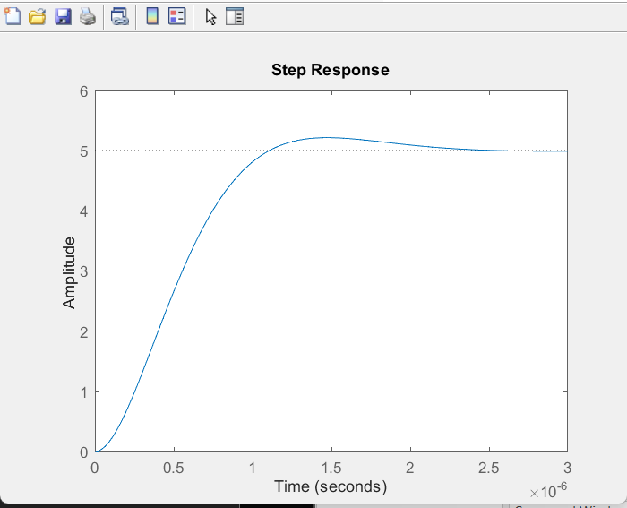
Figure 4: Step response for the uncompensated RLC network.

Lead network
$$G_{clead}= \frac{R_{4}C_{1}\left(s+\frac{1}{{R_{1}C}_{1}}\right)}{R_{3}C_{2}\left(s+\frac{1}{R_{2}C_{2}}\right)}$$
Where:
- R₁ = 24kΩ
- R₂ = 6.2kΩ
- C₁ = 0.01nF
- C₂ = 0.0082nF
- R₃ = 6.2kΩ
- R₄ = 24kΩ
$$G_{clead}= \frac{0.24 x {10}^{-6} s+1}{50.84 x {10}^{-9} s+1}$$

Transfer function | Phase margin(º) | Corner frequency (Hz) | Delay time | %Overshoot | Settling time
G_{p} | 38.8 | 3015113.4 rad/s | 0.00002s | 4.31
G_{p}G_{c(lead)} | 64.5 | 3851777.0 rad/s | 0.000046s | 6.75

Lag network

$$G_{clag}= \frac{R_{4}C_{1}\left(s+\frac{1}{{R_{1}C}_{1}}\right)}{R_{3}C_{2}\left(s+\frac{1}{R_{2}C_{2}}\right)}$$
Where:
- R₁ = 6.2kΩ
- R₂ = 24kΩ
- C₁ = 0.0082nF b
- C₂ = 0.01nF
- R₃ = 24kΩ
- R₄ = 6.2kΩ
$$G_{clag}= \frac{50.84 x {10}^{-9} s+1 }{0.24 x {10}^{-6} s+1 }$$

Transfer function | Phase margin | Corner frequency (Hz) | Delay time | %Overshoot | Settling time
G_{p} | 38.8 | 3015113.4 rad/s | 0.00002s | 4.31
G_{p}G_{c(lag)} | 13.6 | 2960857.6 rad/s | 0.000013s | 3.28

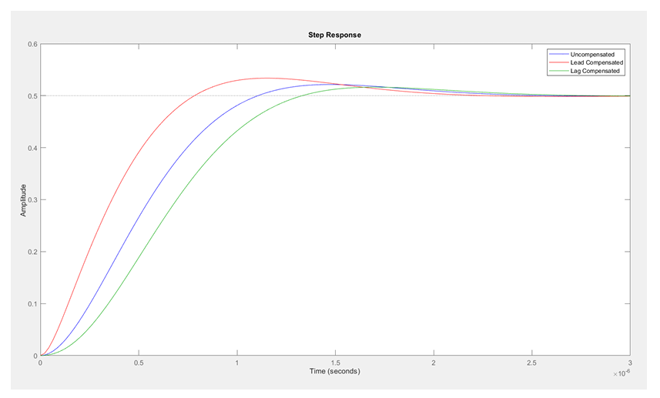
Figure 5. step response
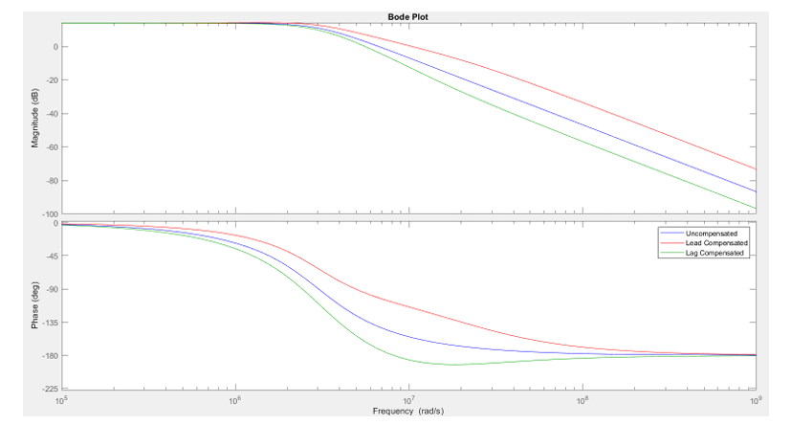
Figure 6. bode plots

Materials and requirements
- Resistors
- 2 - 24kΩ
- 2 – 6.2kΩ
- 2 - 220Ω
- Capacitors
- 1 – 0.0082nF
- 1 – 0.01nF.
- 1 – 2.2nF
- Inductor
- 1 - 100µH
- Power sources
- 5V source.
- 10V source.
- Op amp
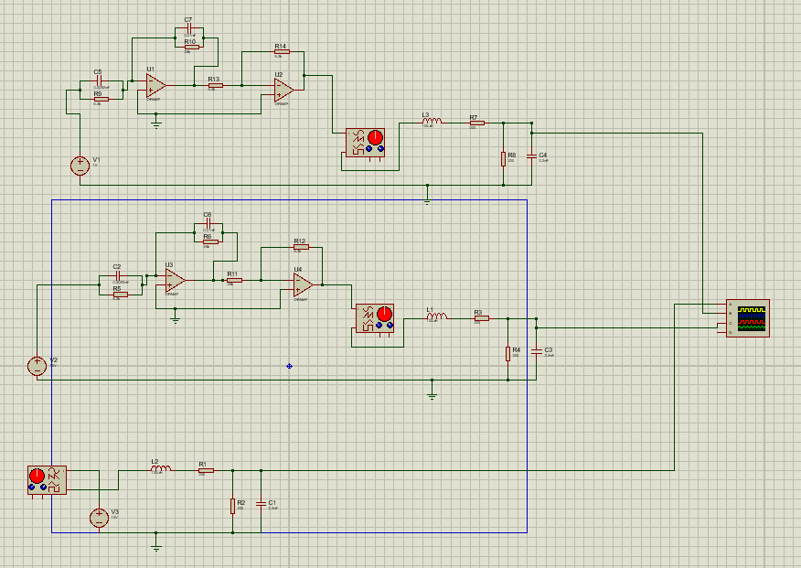
Figure 7 simulated circuit.

- RLC Network Transfer Function \( G_p(s) \):
$$V_{C}\left(s\right)=\frac{10}{(s\left(s^{2}LC+s\left(\frac{L}{R_{2}}+CR_{1}\right)+\left(\frac{R_{1}}{R_{2}}+1\right)\right)}$$

- Lead Compensator Transfer Function \( G_{clead}(s) \):
Where:
- R₁ = 24kΩ
- R₂ = 6.2kΩ
- C₁ = 0.01nF
- C₂ = 0.0082nF
- R₃ = 6.2kΩ
- R₄ = 24kΩ
$$G_{clead}= \frac{0.24 x {10}^{-6} s+1}{50.84 x {10}^{-9} s+1}$$

- Lag Compensator Transfer Function \( G_{clag}(s) \):
Where:
- R₁ = 6.2kΩ
- R₂ = 24kΩ
- C₁ = 0.0082nF b
- C₂ = 0.01nF
- R₃ = 24kΩ
- R₄ = 6.2kΩ
$$G_{clag}= \frac{50.84 x {10}^{-9} s+1 }{0.24 x {10}^{-6} s+1 }$$

3. Laboratory Procedures and Observations
Lead Compensator Analysis
1. The lead compensator circuit was constructed using specified component values.
2. MATLAB was used to plot the Bode and step response for G_p(s), G_clead(s), and G_p(s) . G_clead(s).
3. Recorded data is summarized in Table 1, which shows the increase in phase margin and speed due to lead compensation.

Lag Compensator Analysis
1. The lag compensator circuit was set up as per the requirements.
2. Using MATLAB, Bode and step response plots were generated for G_p(s) , G_clag(s), and G_p(s).G_clag(s).
3. Results, displayed in Table 2, indicated reduced overshoot and a slight decrease in phase margin, highlighting the effect of lag compensation on damping.
4. Results
Step 3: Step Response Analysis for RLC Network and Compensated Systems
1. Uncompensated RLC Network:
Overshoot: 4.31%
Corner Frequency: 3.0151 MHz
2. Lead Compensated Network:
Observed faster response and increased overshoot with a reduced phase margin.
Transfer Function | Phase Margin (°) | Corner Frequency (Hz) | Delay Time (s) | % Overshoot | Settling Time (s)
G_p | 38.8 | 3.0151 e6 | 0.00002 | 4.31 | N/A
G_pG_{clead} | 64.5 | 3.8518 e6 | 0.000046 | 3.28 | Improved
Table 1. Lead Compensated Network Performance

3. Lag Compensated Network:
Added damping reduced overshoot but also decreased the phase margin, with a slightly slower response.
Transfer Function | Phase Margin (°) | Corner Frequency (Hz) | Delay Time (s) | % Overshoot | Settling Time (s)
G_p | 38.8 | 3.0151 e6 | 0.00002 | 4.31 | N/A
G_pG_{clead} | 13.6 | 2.9609 e6 | 0.000013 | 3.28 | Longer
Table 2. Lag Compensated Network Performance

Analysis
Lead compensation increased both phase margin and corner frequency, leading to a faster system response. Lag compensation, conversely, reduced overshoot and settling time, enhancing damping at the cost of a lower phase margin
Significance: Lead networks suit applications requiring fast response, while lag networks provide stability in systems with high-frequency noise or rapid fluctuations.

Conclusion
The experiment successfully illustrated the roles of lead and lag compensators in shaping system dynamics. Lead compensation enhanced response speed and reduced overshoot, making it suitable for fast response applications. In contrast, lag compensation increased damping, reducing oscillations and improving stability in systems prone to noise.

Challenges and Improvements:
Calibration for precise frequency responses was required; minor fluctuations occurred due to component tolerances.
Higher precision components and more stable power sources could reduce response inconsistencies.
Possible sources of error: Oscilloscope calibration and signal generator drift contributed to minor discrepancies in phase measurements.

References
1. MATLAB Documentation for Bode and Step Response Analysis

Appendices
Appendix A: Circuit Diagrams for Lead and Lag Networks
Appendix B: MATLAB Code for Bode Plot and Step Response Analysis
Appendix C: Measured and Calculated Values for Lead and Lag Compensators

